**Assisted Practice: 3.13 Empty an S3 Bucket**

**Step 3.13.1:** Selecting the S3 bucket you want to empty

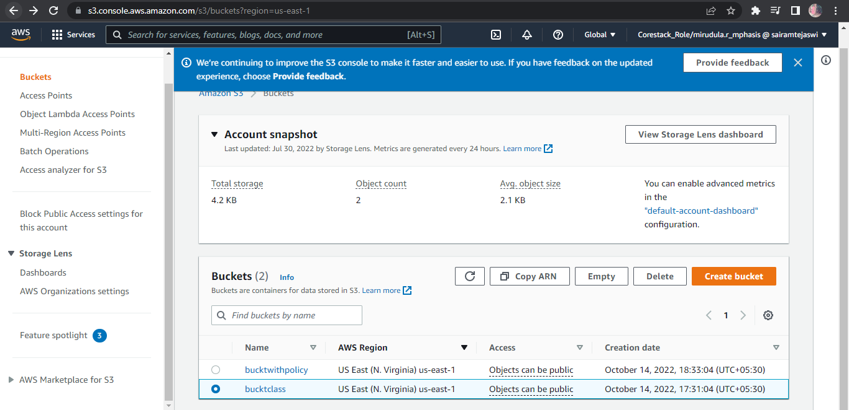

**Step 3.13.2:** Emptying the bucket

* Verify the content present in the bucket

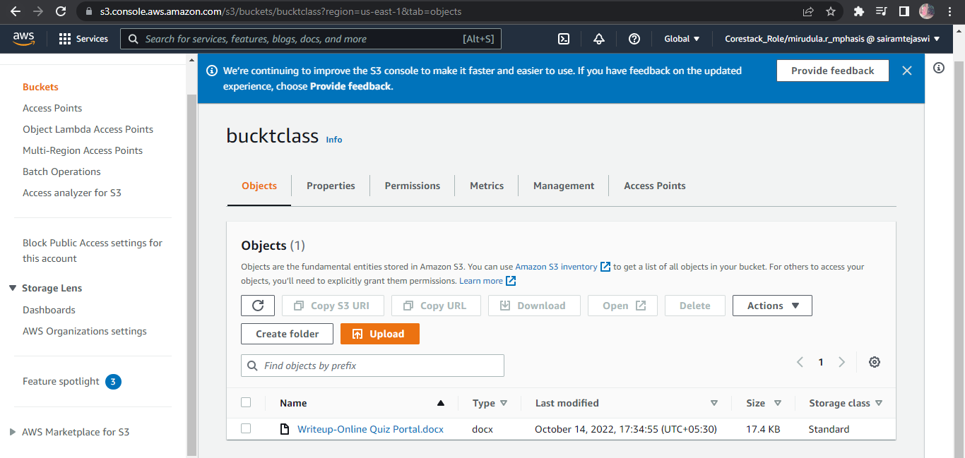

* Empty the bucket

